Name: _______________________ Class: __________ Date: _______
Instructions: Write answers in the right-hand column. Score: ___________ / 50 marks
Section A— Multiple choice (10 marks)

 | Rocks are weathered to form materials that can then form part of a soil. Soils would therefore contain the following material that was originally part of the rock:  A Air  B Water  C Minerals  D Humus | C | 1
 | The agents of erosion are:  A Water, air, wind and sunlight  B Ice, water, gases and rain  C Water, wind and rain  D Wind, water and ice | D | 1
 | Soils are not renewable because they:  A can be eroded.  B are replaced too slowly.  C are formed from weathering of rocks.  D can be weathered. | B | 1
 | 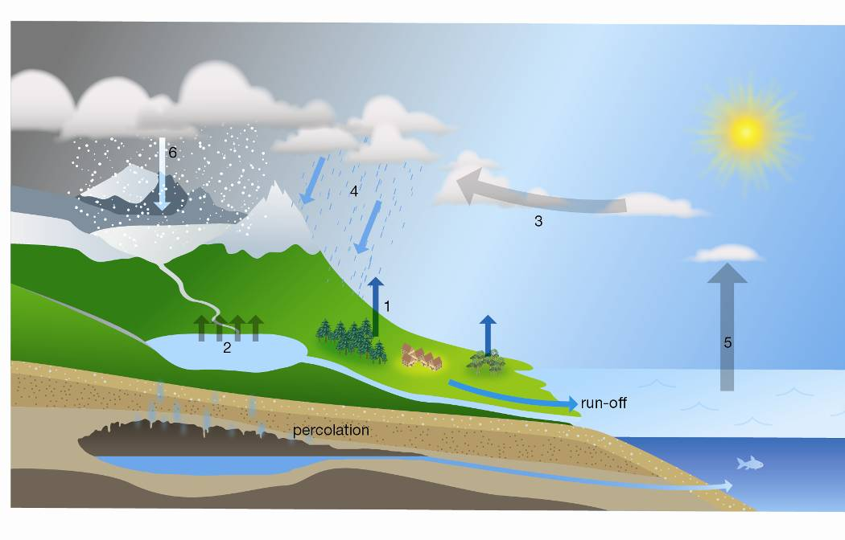  Deduce the process occurring at position 2.  A Precipitation  B Evaporation  C Condensation  D Transpiration | B | 1
 | Deduce the process that has occurred at position 1.  A Precipitation  B Evaporation  C Condensation  D Transpiration | C | 1
 | Select the list of renewable energy sources from the alternatives below.  A Energy from coal, geothermal energy, tidal energy  B Wind energy, tidal energy, hydroelectric energy  C Solar energy, nuclear energy, wind energy  D Energy from coal, nuclear energy, wind energy | b | 1
 | Select the alternative that cannot be used to produce biomass.  A Decomposing fruit peelings and grass clippings  B Human sewage and animal wastes  C Fermented sugarcane  D Recycled aluminium | D | 1
 | Recall the largest source of evaporation in the water cycle.  A The oceans, because they are the largest bodies of water  B Vegetation, because the leaves of trees and other plants have such a large surface area  C Turbulent rivers and streams and waterfalls where there is a lot of spray going into the air  D Spray irrigation of large agricultural areas | A | 1
 | Human activities have upset the natural water cycle in many places. Select the human activity that is an attempt to restore an aspect of the natural water cycle.  A Irrigation of crops  B Replacing forest with food crops  C Building of dams  D Construction of rain gardens | D | 1
 | 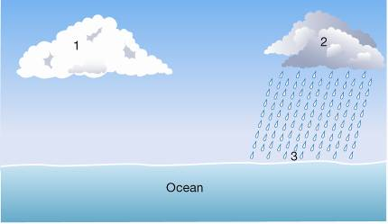  Using the information provided in the diagram, deduce which of the following statements is untrue.  A The air at 1 is saturated.  B Evaporation is taking place at 3.  C Run-off will occur when the precipitation reaches 3.  D The water droplets at 1 are smaller than at 2. | C | 1

Section B— Short answer ( marks)

- ` | a Define what is meant by a renewable resource  b Explain why rocks and soils are not renewable resources, but living things are renewable. | a A renewable natural resource is one that is replaced by natural processes that occur on Earth in a timescale less than an average human life.  b Rocks and soils cannot be replaced within a human lifetime, whereas living things reproduce, replacing themselves, usually within a human lifetime. | 3
 | a Name two processes that return gases to the air.  b Describe a process in animals that affects oxygen and carbon dioxide levels in the air | a Photosynthesis, breathing (could also say combustion, evaporation, etc.)  b Breathing removes oxygen from the air and releases carbon dioxide back into the air. | 3
 | Hannah and Omar used the following equipment to study how plants affect the air.  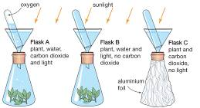  a Explain what would have happened in flask A.  b Explain why flask B would have a different result from flask A. | a In flask A, carbon dioxide and water would have combined using the energy of sunlight and formed sugar and oxygen. The oxygen escaped into the test-tube.  b Flask B had no carbon dioxide, and plants use that in photosynthesis. So no oxygen would have been made. | 4
 | a Explain the difference between a renewable and a non-renewable energy source.  b State an example of each type. | a A renewable energy source is one that can be used over and over again and is replaced by natural processes that occur in a timescale shorter than an average human life. Non-renewable energy sources are limited in supply and will one day run out if they continue to be used.  b Solar, hydroelectric, tidal or wind energy are examples of renewable energy sources. Examples of non-renewable energy sources are oil, coal and nuclear energy. | 2
 | a Describe what occurs during the process of nuclear fission.  b Recall one advantage of using nuclear energy.  c Recall one disadvantage associated with the use of nuclear energy. | a During the process of nuclear fission a chain reaction occurs. This releases huge amounts of energy and radiation.  b Nuclear fission releases enormous amounts of energy using only a small amount of fuel. It also produces no greenhouse gases.  c There is always a safety risk associated with ensuring that any nuclear reaction is controlled. Also, the nuclear waste produced as a by-product of nuclear fission is hazardous and very difficult to safely dispose of. | 3
 | The diagram below shows the equipment set up to model the water cycle.  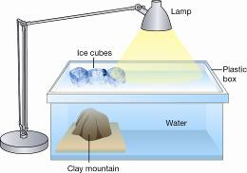  A Explain which part of the natural water cycle is represented by the heat lamp.  B Deduce the effect of the heat lamp.  C Explain the effect the ice cubes would have and what this represents in the water cycle.  D Propose why the clay mountain was added to the model. | a The heat lamp represents the Sun.  b The heat lamp would cause the water to evaporate in the box, just as the Sun causes water to evaporate from oceans and rivers.  c The ice would cool the air under it, causing condensation on the lid of the box. If there was enough condensation, precipitation could occur.  d The clay mountain could have been added to encourage precipitation. | 4
 | The diagram below shows a soil profile.  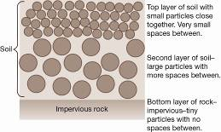  a Describe what could happen to water falling on the surface of the soil.  b Compare what would happen to the water if there was extremely heavy rainfall rather than a steady shower of rain. | a The water would percolate slowly through the top layer of soil. It would then collect in the spaces between the soil particles in the lower level. It would not be able to move any further down because of the impervious rock underneath.  b In very heavy rainfall there may not be time for the water to move through between the closely packed soil particles of the upper layer. The water would flow over the soil as run-off. In less heavy rain, more of the water would be able to penetrate the soil and run-off would be less. | 4
 | Explain how dingo tracks such as those below may have helped Indigenous Australians to survive.  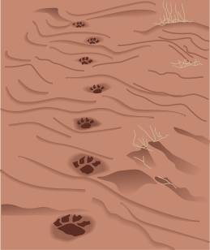 | Dingo tracks could lead to a source of water in what appeared to be a dry waterless area. | 1
 | Propose how the equipment shown below could be used to provide a source of water if you were lost in the bush.  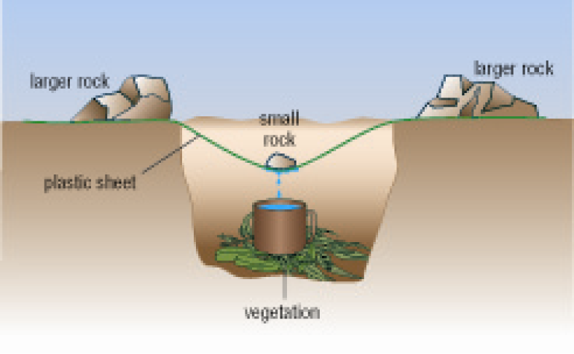 | Water evaporates from the vegetation. Water vapour rises and condenses on the plastic sheet. The water runs down the inside of the plastic sheet and collects under the small rock. When there is enough water it starts to drip down into the cup. | 3
 | Sometimes gardeners place plastic bottles over young plants as shown below. Gardeners suggest that these plants do not need to be watered as often but still do not dry out. Explain why this happens.  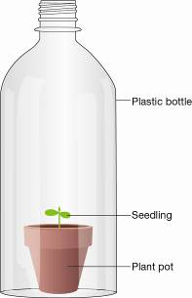 | Transpiration and evaporation from soil surface would be reduced. A lot of the water vapour will be trapped inside the bottle because it has a very narrow opening. The humidity will increase and the evaporation rate will slow down. Water may condense on the top and sides of the bottle and this may fall back into the soil. | 4

Section C— Thinking scientifically (10 marks)

 | Some students were asked to classify some of Earth’s resources into renewable resources and non-renewable resources. Their answer is shown in the following table:  Renewable resources  Non-renewable resources  1 Water  7 Rocks  2 Natural gas  8 Air  3 Sunlight  9 Coal  4 Soil  10 Petroleum  5 Waves  11 Wind  6 Hydro-electric  12 Nuclear  Which resources (using the number) did the students classify incorrectly?  A 1, 4, 7, 8  B 2, 7, 8, 12  C 2, 4, 8, 11  D 1, 4, 8, 11 | C | 1
 | Goran and Diana did an experiment on soils to study how water passed through them. They set up the equipment shown below.  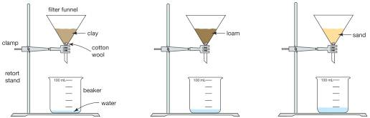  They poured 100 mL of water into each sample of soil and after 10 minutes they recorded their results in the table below.  Soil type  Water in beaker (mL)  Clay  5  Loam  15  Sand  33  Which of the following is a correct deduction made by the students?  A Sand holds onto water better than clay and loam.  B More water drains through clay than through sand and loam.  C Loam is more permeable than sand.  D Clay is less permeable than sand and loam. | D | 1
 | Siobhan and Ivan were studying erosion on a slope. They used the equipment shown below.  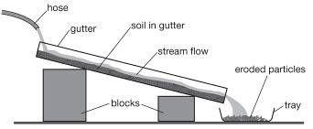  Their results are shown in the table below.  Steepness of slope  Stream speed  Mass of particles (g)  Largest particle  size (mm)  Gentle  Slow  18  0.2  Moderate  Moderate  39  2.0  Steep  Fast  57  3.0  Which of the following is a correct deduction made by the students?  A Larger particles and more sediment are carried by streams on steeper slopes.  B The smallest particle that can be carried by a stream on a steep slope is 3.0 mm.  C A stream on a steep slope can carry 57 g of soil.  D Fast streams will carry 57 g of particles of 3.0 mm size. | A | 1
 | A tidal barrage uses the power of water flowing from high to low tide to turn turbines and generate electricity. The rising water level is trapped by a series of gates that shut off the flow of the water.  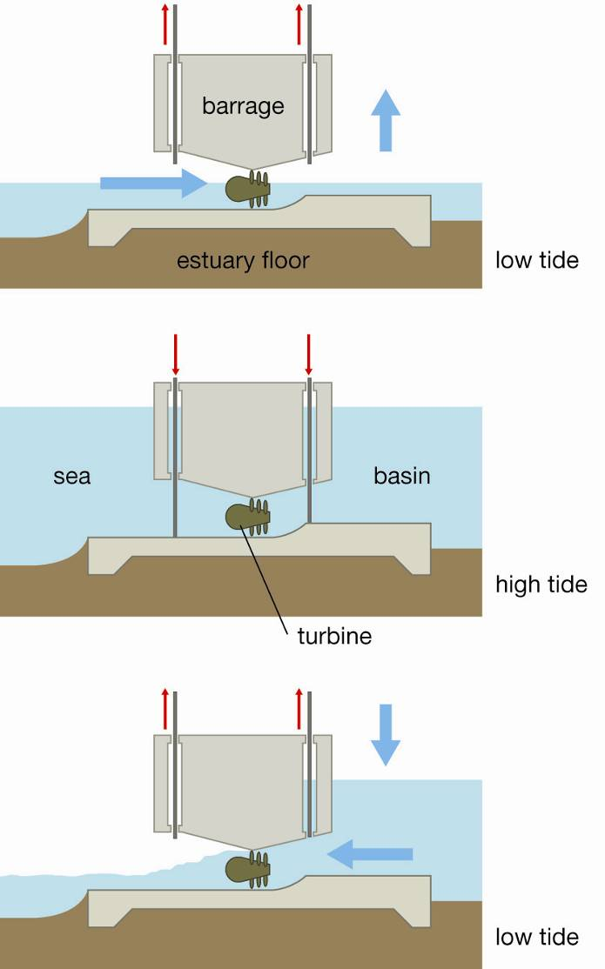  Study the three diagrams of the process shown above. The correct sequence of these steps is:  A A, B, C  B B, A, C  C C, A, B  D B, C, A | C | 1
 | This figure below shows how a geothermal power plant operates. Using this diagram, select the alternative that correctly outlines the flow of energy used in this process.  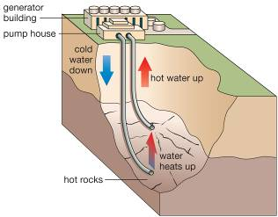  A Hot water is pumped down into the Earth’s crust. It is cooled by rocks and then cooler water is pumped back up to the surface.  B Cold water is pumped down into the Earth’s crust. It is heated by rocks and then hot water is pumped back up to the surface.  C Hot water is pumped down into the Earth’s crust. It is heated further by rocks and then this hotter water is pumped back up to the surface.  D Cold water is pumped down into the Earth’s crust. It is cooled even more by rocks and then the very cold water is pumped back up to the surface. | B | 1
 | Transpiration is water loss from plants, especially from the leaves. Which of the following events is least likely to occur.  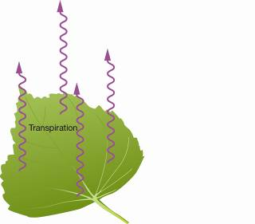  A The rate of transpiration will slow down as the air above the leaf becomes saturated.  B The rate of transpiration will increase if a breeze begins to blow over the leaf.  C Transpiration will continue at a constant rate as long as there is water in the leaf, whatever the conditions around the leaf.  D The rate of transpiration will increase as the temperature rises in the middle of the day. | C | 1
 | Air is saturated (full of water vapour) when humidity reaches 100%. Which of the following conditions will allow least evaporation to occur from a leaf?  A Temperature of 15°C with humidity at 80%  B Temperature of 17°C with humidity at 75%  C Temperature of 20°C with humidity at 60%  D Temperature of 25°C with humidity at 50% | A | 1
 | Referring to the pie chart below, identify the percentage of irrigation water used to provide fruit and vegetables.  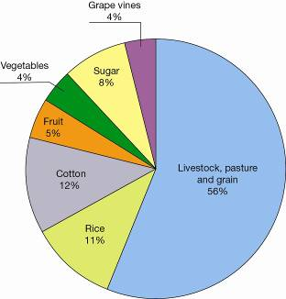  A 5%  B 56%  C 9%  D 12% | C | 1
 | Referring to the pie chart below, calculate which crop uses more water then select the correct comparison.  A Sugar uses more water than rice.  B Cotton uses more water than sugar.  C Grape vines use more water than vegetables.  D Grape vines use more water than livestock, pasture and grain. | B | 1
 | Pervious rock allows water to percolate into it. Impervious rock does not allow water to percolate into it. Using the information in the diagram below, deduce which of the following events is least likely to occur.  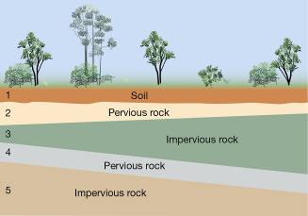  A There may be underground water in layers 2 and 4.  B An aquifer may develop in layer 4.  C Layers 3 and 5 will have water percolating through them.  D Water may enter layer 4 somewhere else a long way from this site. | C | 1

